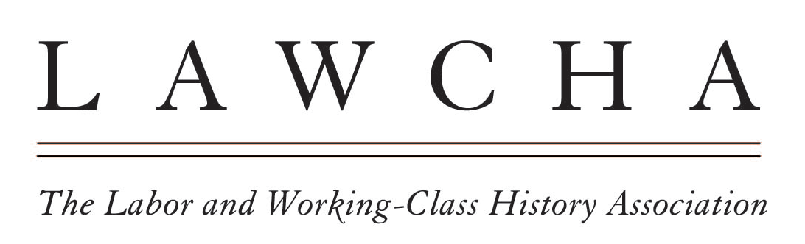The Labor and Working Class History Association, which represents historians of labor unions and working-class people, stands in solidarity with the 25,000 members of the United Faculty of Florida who are waging a struggle to defend academic freedom, the integrity of higher education, and the rights of students to choose their educational programs free of state interference.
We are gravely concerned over the introduction in the Florida State Legislature of proposals (Senate Bill 256 and House Bill 1445) that would revise state labor laws to weaken the power of organized labor.
Among the proposals is the mandate that unions maintain membership of 60 percent of eligible workers or face decertification; they would also eliminate dues check-off for most public-sector unions, instead requiring members to mail in their dues.
These measures are clearly designed to chip away at union membership and unions’ strength. (Notably, firefighters, police officers and correctional officers will be exempt from these provisions.) These proposals draw on decades of conservative hostility to public-sector labor unions, and are part of a continuous effort on the right to demonize both the public sector and the people who work in it.
But they are especially alarming today given the ongoing struggle in Florida over academic freedom, as represented by House Bill 999. Unions protect tenure; they can bargain over matters related to academic freedom; and they protect teachers and faculty from arbitrary dismissal or other punitive actions. On a political level, faculty unions in Florida are among the few organizations with the sustained power to challenge Boards of Trustees and state legislators who want to control what is taught in Florida’s classrooms.
Currently, collective bargaining agreements negotiated by United Faculty of Florida chapters at their respective colleges and universities protect academic freedom, tenure, and the principles of shared governance. Governor DeSantis seeks to destroy the United Faculty of Florida and collective bargaining in order to seize control of higher education and gain complete control over hiring, curriculum, and all significant administrative decisions in higher education. LAWCHA opposes these tactics and urges our members and colleagues to support the United Faculty of Florida and all unions in Florida during these ominous times.
Finally, what happens in Florida has clear national significance. In addition to Governor Ron DeSantis’s political ambitions, other states are likely to model efforts to overhaul their educational systems in keeping with what he is able to achieve there.
We at LAWCHA stand for a different vision of the university and the classroom, one in which educators at all levels have the power to make decisions about what to teach based on scholarly expertise rather than political whim. Labor rights, we believe, are an essential precondition for academic and intellectual freedom.

