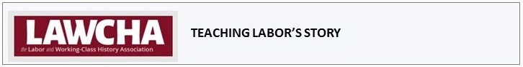
Document 9.1

Triumph of the Paraprofessionals, August 22, 1970
Op-Ed written by civil rights organizer Bayard Rustin on the signing of the first union contract for paraprofessional educators (classroom and school support staff) in New York City. It was published in the New York Amsterdam News, the city’s largest black-owned newspaper.

June 30, 1922

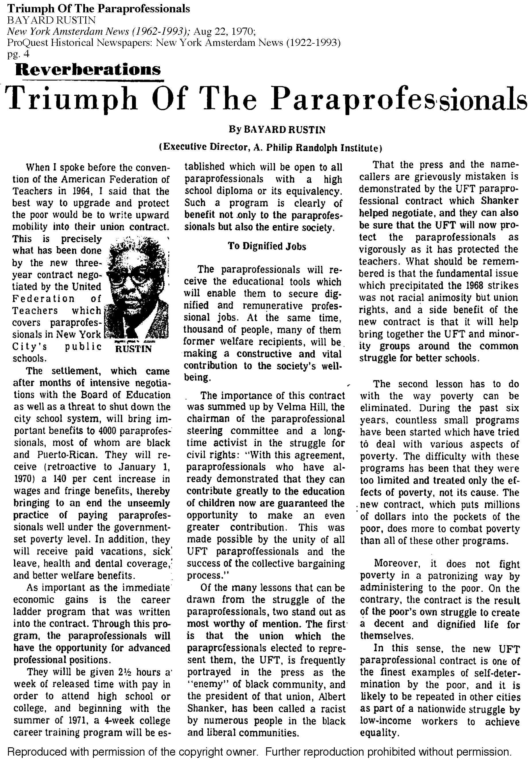
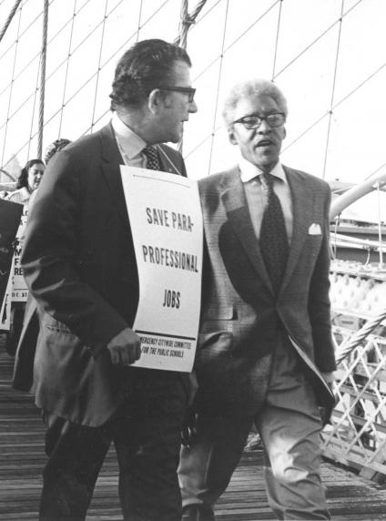  Albert Shanker and Bayard Rustin march in support of collective bargaining rights for paraprofessionals.  October 6, 1970. Credit: Walter P. Reuther Library. | 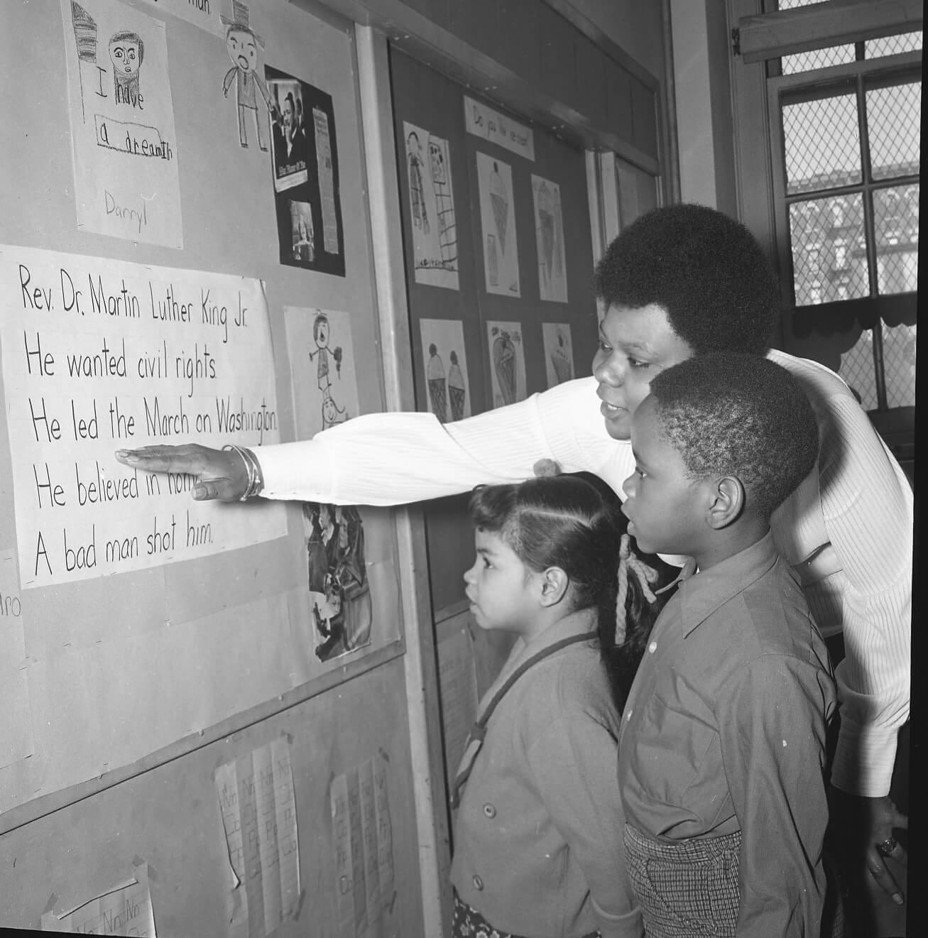  Paraprofessional Doris Hunter teaches about the life of Dr. Martin Luther King, Jr. at PS 25 in Brooklyn in 1970. Many paraprofessionals took the lead in bringing African-American, Latino, and Asian-American history and culture into public schools in New York City. United Federation of Teachers. Credit: Hans Weissenstein Negatives Collection, Tamiment Library and Robert F. Wagner Labor Archives, NYU.
Teacher Sheri McCormick (left) and paraprofessional Shashala Saulsbury work on a reading assignment with students. Credit: UFT | 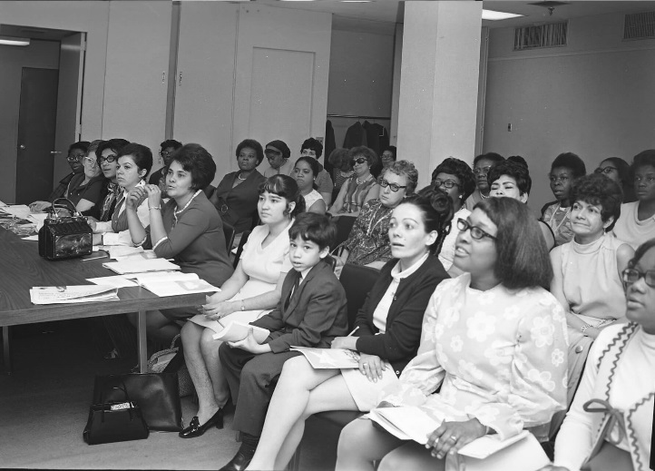  Paraprofessionals taking a high-school equivalency exam, Manhattan, 1970. The UFT’s landmark paraprofessional contract created opportunities for education and advancement for thousands of working-class women. Credit: United Federation of Teachers Hans Weissenstein Negatives Collection, Tamiment Library and Robert F. Wagner Labor Archives, NYU.

DOCUMENT 9.1

Document Title:
TRIUMPH OF THE PARAPROFESSIONALS
Document Type: newspaper Op-Ed [opinion-editorial]
Brief Description:
This opinion piece by civil rights organizer Bayard Rustin celebrates the signing of the first union contract for paraprofessional educators -- community-based classroom and school support staff, nearly all of them black and Hispanic women -- in New York City. It was published in the New York Amsterdam News, the city’s largest black-owned newspaper, in 1970.

Historical Era

POSTWAR UNITED STATES (1945-early 1970S)

Document Selection and Teaching Guide by:
Nick Juravich, Andrew W. Mellon Foundation Postdoctoral Fellow, New York Historical Society

SOURCING THE SOURCE
Bayard Rustin published this opinion piece in the New York Amsterdam News after working closely with New York City’s paraprofessional educators and their union, the United Federation of Teachers (UFT), to organize paraprofessionals and win a contract from the city’s Board of Education. The Amsterdam News was the city’s pre-eminent black-owned publication, with a wide African-American readership locally and nationally. Rustin was a sporadic contributor to their opinion pages, writing about civil rights, politics, and labor.

Intended Audience: Rustin’s intended audience is the readership of the Amsterdam News, primarily black New Yorkers. His choice of venue was deliberate. The UFT had struck three times in the fall of 1968 to stop an experiment in “community control” of schools by black and Puerto Rican New Yorkers. Rustin was one of the only black leaders to stand by the UFT during the strikes. He was criticized for his stance in the Amsterdam News by authors who argued that the union’s strike was a racist attack on black and Puerto Rican communities, not a labor dispute. Afterward, Rustin believed the unionization of paraprofessional educators with the UFT, and their successful contract campaign, represented a rehabilitation of his political efforts to build connections between the civil rights movement and the labor movement. By celebrating the contract in the Amsterdam News, he hoped to convey this message to a wide black audience.

UNDERSTANDING THE SOURCE
- Historical Context:
Bayard Rustin’s op-ed, “Triumph of the Paraprofessionals,” sits at the intersection of three histories: (1) the history of the civil rights movement, (2) the history of the War on Poverty, and (3) the history of the labor movement. These histories are sometimes taught separately, but this document shows us how they are connected. Understanding the collaborations and tensions between the civil rights movement, the War on Poverty, and the labor movement expands our understanding of all three.

(1) The civil rights movement is best known as a series of struggles to desegregate schools and public accommodations - including public transit and lunch counters - in the American South in the 1950s and 1960s. However, one of the core demands of civil rights organizers all across the country was jobs. Fighting for jobs meant fighting for equal access to employment, equal pay, and equal treatment at work. In the early 1960s, when the American economy was booming, the Civil Rights Movement helped to expose the persistence of poverty, particularly among black and Hispanic Americans living in cities. The 1963 March on Washington, at which Dr. Martin Luther King Jr. gave his famous “I Have a Dream” speech, was officially titled “The March on Washington for Jobs and Freedom.” Bayard Rustin, a lead organizer for that march, believed the Civil Rights Movement should work closely with the labor movement to realize the goal of equal opportunity.

(2) In 1964, President Lyndon Johnson declared a “War on Poverty.” He pushed Congress to pass new laws to allocate billions of dollars for this fight. Johnson and the Democratic Party majority pushed for programs focused on opportunity--educational and training initiatives--not direct job creation.

War on Poverty programs also included commitments to the “maximum feasible participation” of poor people. While Johnson and his administrators did not intend to use employment to end poverty, these programs did, in fact, create tens of thousands of new jobs in “human services”: education, health care, and social work. In New York City, civil rights organizers interpreted “maximum feasible participation” to mean that poor and working-class black and Hispanic people should be hired to work in these new positions. They argued that doing so would improve services, connect service providers to the communities they served, and create jobs. They used petitions, protests, and local experiments to demand local hiring and to show that such programs could work. In New York, their pressure paid off in education in the spring of 1967, when the Board of Education hired 75 women to work as “paraprofessionals” in kindergarten. These workers were hired to assist students in classrooms and help teachers connect to parents and community members. The program was so effective that the Board had hired 10,000 “paras” by 1970.

(3) Public-sector unions, and especially teacher unions, expanded rapidly in the 1960s. The American Federation of Teachers, founded in 1916, doubled in size, thanks in large part to the founding of the United Federation of Teachers in New York City in 1960. The UFT won its first contract with the city in 1962. Teachers unionized for many reasons. Their pay was low compared to unionized workers. Their working conditions were poor, often requiring them to teach up to 60 children in each class. Their principals often imposed arbitrary and unfair restrictions on them, including regulations on women’s clothing and loyalty oaths. By unionizing, teachers not only improved the conditions of their jobs, but asserted their professional status.

In these same years, schools in the north were segregated, and the teaching corps was segregated, too. In 1968, 60% of New York City’s public school students were black or Hispanic, but only 9% of teachers were. After several failed campaigns to integrate New York City’s public school system, many activists began calling for “community control” of schools. In 1968, the city created three “experimental districts” for this purpose. The UFT opposed this move, as it believed these districts would undermine its contract and teachers’ hard-won professionalism. When one Brooklyn district transferred 19 white teachers that the community’s elected representatives found ineffective, the union went on strike. The resulting struggle closed schools for six weeks, and led the State of New York to cancel the experiment. Most of the city’s black and Hispanic leaders condemned the UFT for destroying the districts under “community control.”

Paraprofessional educators found themselves right in the middle of this fight. They worked in schools, and many sympathized with teachers, but unlike teachers, they came from local neighborhoods and believed in community control. Many “paras” had been involved in the civil rights movement and campaigns to hire local residents, and had opposed the strike.

Paraprofessional educators in these years experienced poor pay, a lack of job security, and poor treatment from managers. Some also hoped to become teachers themselves. Even though many disagreed with the union’s leaders, they sought the benefits of unionization, and voted to join the UFT in 1969. After a two-pronged campaign in the spring of 1970, in which both the Amsterdam News and rank-and-file white teachers expressed public support for paras, the Board of Education sat down to negotiate a contract over the summer.

The result is described in this document. The working-class black and Latina women who organized and joined the UFT more than doubled their salaries, secured their jobs, won health care and other fringe benefits, and created a “career ladder” to become teachers, with paid time off to attend classes and summer stipends as well. In 1971, the career ladder program opened at the City University of New York. For 4 years, until a citywide fiscal crisis undermined funding for it, over 6,000 paras attended school every semester, earning GEDs and associate’s, bachelor’s and master’s degrees. By the early 1980s, over 2,000 had become teachers.

- Meaning and Significance of the Source
Rustin’s editorial shows how, in his vision, organizing paraprofessional educators brought together the Civil Rights Movement, the War on Poverty, and the Labor Movement. He expresses his hope that the contract “will help bring together the UFT and minority groups around the common struggle for better schools.” He also argues that unions are essential to fighting poverty, writing “the new contract, which puts millions of dollars into the pockets of the poor, does more to combat poverty” than most other War on Poverty programs. Rustin also believes that this contract represents a successful example of “maximum feasible participation,” calling it “one of the finest examples of self-determination by the poor.” While the unionizing paraprofessional educators did not erase the bad feelings that remained from the 1968 strikes, it brought the voices of black and Hispanic parents into classrooms and the union, and created new opportunities for collaboration between educators and communities in the 1970s.

Rustin also wrestles with the question of “professionalism,” which was valued by teachers and their unions but seen by many Civil Rights Movement as a way to preserve segregation on the job and keep community members at a distance. For Rustin, the creation of a “career ladder” program that allows paras to train - for free - to become teachers opens up the category of “professional” to a whole new group of people. It also creates a link between teachers and paras, who can view one another as educators along a continuum. In the first paragraph of the editorial, Rustin describes this as “writ[ing] upward mobility into their union contract.”

Finally, Rustin’s editorial predicts that the contract in New York will launch “a nationwide struggle by low income workers to achieve equality.” Rustin knew when he wrote this that the AFT, the UFT’s parent union, was planning a national effort to organize paras, one that would add 100,000 of these workers to their union by 1988. Paraprofessional hiring also continued to expand. 500,000 people were hired nationwide between 1965 and 1975, and today, approximately 1.2 million “paras” work in public schools in many contexts.

Rustin’s editorial shows how, in his vision, organizing paraprofessional educators brought together the Civil Rights Movement, the War on Poverty, and the Labor Movement. He expresses his hope that the contract “will help bring together the UFT and minority groups around the common struggle for better schools.” He also argues that unions are essential to fighting poverty, writing “the new contract, which puts millions of dollars into the pockets of the poor, does more to combat poverty” than most other War on Poverty programs. Rustin also believes that this contract represents a successful example of “maximum feasible participation,” calling it “one of the finest examples of self-determination by the poor.” While the unionizing paraprofessional educators did not erase the bad feelings that remained from the 1968 strikes, it brought the voices of black and Hispanic parents into classrooms and the union, and created new opportunities for collaboration between educators and communities in the 1970s.

Rustin also wrestles with the question of “professionalism,” which was valued by teachers and their unions but seen by many Civil Rights Movement as a way to preserve segregation on the job and keep community members at a distance. For Rustin, the creation of a “career ladder” program that allows paras to train - for free - to become teachers opens up the category of “professional” to a whole new group of people. It also creates a link between teachers and paras, who can view one another as educators along a continuum. In the first paragraph of the editorial, Rustin describes this as “writ[ing] upward mobility into their union contract.”

Finally, Rustin’s editorial predicts that the contract in New York will launch “a nationwide struggle by low income workers to achieve equality.” Rustin knew when he wrote this that the AFT, the UFT’s parent union, was planning a national effort to organize paras, one that would add 100,000 of these workers to their union by 1988. Paraprofessional hiring also continued to expand. 500,000 people were hired nationwide between 1965 and 1975, and today, approximately 1.2 million “paras” work in public schools in many contexts.

GLOSSARY
American Federation of Teachers: One of two major teacher unions in the United States; the other was the National Education Association, or NEA. Unlike the NEA, which styled itself a professional association and did not organize workers or bargain for contracts until the 1970s, the AFT was founded, in Chicago in 1916, as a union for teachers. The union struggled to win contracts until the post-WWII era, when many cities changed their laws to allow teacher unions to bargain collectively. Today, the AFT is primarily a union of urban teachers, totaling nearly 1.7 million members.
Career Ladder: A program of on-the-job training that allows entry-level workers with limited formal educational experience to get their educations and move up to “professional” status (in this case, becoming teachers) while continuing to work. Particularly valuable for “nontraditional” students who cannot afford to take time off to go to school.
Collective Bargaining: The government-regulated process by which employers and unions sit down together to shape a union contract.
Fringe Benefits: Benefits that are not wages; in this case, health and dental care and access to the “Career Ladder” program.
Paraprofessional: Also known as teacher aides, auxiliary teachers, education support professionals (ESPs) or “paras,” these educators were hired locally - primarily from among the mothers of schoolchildren - in the 1960s. They were originally tasked with improving instruction in classrooms by working alongside the teacher and working with parents and teachers to bridge gaps between schools and communities. Today, “paras” perform a wide range of functions in schools, including individual support for students in special and bilingual programs, classroom assistance, and parent outreach.
Remunerative: well-paying
United Federation of Teachers [UFT]: New York City’s teachers union, created in 1960 through the “uniting” of several smaller teacher organizations. The UFT won their first contract in 1962, and has been the largest local union of the American Federation of Teachers since. The union today represents 185,000 members, including teachers, paras, other school workers, and school and hospital nurses.
War on Poverty: A “war” declared by President Lyndon Johnson in 1964 and fought with a series of federally-funded programs, most notably through the Economic Opportunity Act of 1964, which created the Office of Economic Opportunity, or OEO, which in turn administered the Community Action Program (CAP), a series of programs aimed at funding locally-led efforts to combat poverty through the “maximum feasible participation” of poor Americans. Funding and support dwindled due to military commitments in Vietnam and rising political backlash, and President Richard Nixon declared the war over in 1973, with the shuttering of the OEO.
Welfare: A program of cash assistance created in the New Deal (1930s) and originally paid as “aid to dependent children” (ADC) living without a breadwinning male head of household. Renamed “Aid to Families with Dependent Children” (AFDC) in the 1960s, the program expanded rapidly as civil rights organizers pushed cities to get rid of racist and exclusionary policies and support black families. Often described as “welfare,” the program faced increasing attacks by politicians in the 1970s and 1980s, and was eventually repealed in 1996 under President Bill Clinton.

QUESTIONS -- DISCUSSION POINTS
Source Specific
- What kinds of things did New York City’s paraprofessional educators win in their contract? What is Bayard Rustin most excited about? Why?
- What are the two main lessons that Rustin learned from the unionization of paraprofessionals?
- Paraprofessional educators lived and worked in black and Hispanic communities that had opposed the 1968 UFT strike. How do you think the “paras” explained their decision to their neighbors, friends, and fellow parents?

Historical Era - essential questions [2-3 questions]
- How does Rustin try to connect the Civil Rights Movement, issues of poverty, and the labor movement to each other? Why were there tensions between these movements?
- How did the expansion of the federal government during the War on Poverty make new kinds of civil rights and labor organizing possible?

Labor & Working Class History – essential questions [2-3 questions]
- What does it mean to be a paraprofessional?
- What did paraprofessional educators hope to gain by joining labor unions?
- Why do social movements - including the civil rights movement and the women’s movement - sometimes conflict with the goals of labor unions?
- How does including the story of paraprofessional educators help us rethink the history of the labor movement?

CURRICULAR & PROFESSIONAL DEVELOPMENT CONNECTIONS
Common Core Standards: [http://www.corestandards.org/ELA-Literacy/RH/11-12/ ]
CCSS.ELA-Literacy.RH.11-12.1 Cite specific textual evidence to support analysis of primary and secondary sources, connecting insights gained from specific details to an understanding of the text as a whole.
CCSS.ELA-Literacy.RH.11-12.2 Determine the central ideas or information of a primary or secondary source; provide an accurate summary that makes clear the relationships among the key details and ideas.
CCSS.ELA-Literacy.RH.11-12.3 Evaluate various explanations for actions or events and determine which explanation best accords with textual evidence, acknowledging where the text leaves matters uncertain.
CCSS.ELA-Literacy.RH.11-12.5 Analyze in detail how a complex primary source is structured, including how key sentences, paragraphs, and larger portions of the text contribute to the whole.
CCSS.ELA-LITERACY.RH.11-12.6 Evaluate authors' differing points of view on the same historical event or issue by assessing the authors' claims, reasoning, and evidence.
CCSS.ELA-Literacy.RH.11-12.8 Evaluate an author’s premises, claims, and evidence by corroborating or challenging them with other information
CCSS.ELA-LITERACY.RH.11-12.9 Integrate information from diverse sources, both primary and secondary, into a coherent understanding of an idea or event, noting discrepancies among sources.
Curricular Connections:
NCHS US Era 9 Standard 1: The student understands the extent and impact of economic changes in the postwar period; and is able to analyze the continued gap between poverty and the rising affluence of the middle class.
This document highlights the gap between the middle-class standard of living enjoyed by unionized workers and the persistent poverty experienced by working-class African-American and Latina women, even those who worked, in American cities. By unionizing, Rustin notes, the women who worked as paraprofessionals sought to move from the ranks of the “working poor” to the middle class.

NCHS US Era 9 Standard 3: The student understands the “New Frontier” and the “Great Society”; and is able to evaluate the legislation and programs enacted during Johnson’s presidency.
This document highlights the impact of the 1965 Elementary and Secondary Education Act (ESEA), which allocated $1.3 billion dollars to public schools serving children living in poverty. The ESEA allowed many schools to experiment with new approaches to education, including hiring local women, mostly mothers, to work as “paraprofessionals” in a variety of classroom and community settings to improve instruction, better connect schools and communities, and create jobs.

NCHS US Era 9 Standard 3: The student understands the “New Frontier” and the “Great Society”; and is able to assess the effectiveness of the “Great Society” programs.
A core debate among historians is whether the Great Society went far enough in its intervention in the American economy. Traditional interpretations suggest that the “War on Poverty” paled in comparison to the New Deal of the 1930s. The “New Deal,” the story goes, transformed the structure of the American economy by creating jobs directly, but the War on Poverty merely sought to integrate poor people into the existing structure of the economy through educational and behavioral interventions in their lives. A related critique argues that while the New Deal funneled money to existing institutions, the War on Poverty created new ones, which lacked political support to sustain them. However, as Rustin notes, “paraprofessional” programs, which were funded directly by War on Poverty legislation, created thousands of jobs for poor and working-class women of color. They also created these jobs within existing educational bureaucracies. A new strand of history on the War on Poverty emphasizes the leadership of black and Latina women in building a “War on Poverty from the grass roots up.” Scholars writing in this vein have argued that despite the paternalistic assumptions of elite policymakers and the limited scope of their vision for addressing poverty through individual behavior, woman organizers on the ground took control of federal programs and monies and turned them toward the goals of the black freedom struggle: jobs, freedom, and equality. Rustin’s editorial places paraprofessional programs squarely within this vein of scholarship. By unionizing, the women who worked as paraprofessionals secured their jobs and expanded their roles beyond what elite policymakers had originally intended.

NCHS US Era 9 Standard 4: The student understands the “Second Reconstruction” and its advancement of civil rights; and is able to analyze the leadership and ideology of Martin Luther King, Jr. and Malcolm X in the civil rights movement and evaluate their legacies.
This editorial was written by Bayard Rustin, Martin Luther King Jr.’s close advisor and the organizer of the March on Washington, at which King was the most prominent speaker. Both King and Rustin began to advance systemic critiques of the American economy and the perpetuation of poverty in the late 1960s, with King launching a “Poor People’s Campaign” before he died, and joining unionized Memphis sanitation workers on their picket lines in 1968, where he was assassinated. While King’s legacy is contested, Rustin believed the work of unionizing black workers further these goals.
NCHS US Era 9 Standard 4: The student understands the “Second Reconstruction” and its advancement of civil rights; and is able to assess the role of the legislative and executive branches in advancing the civil rights movement and the effect of shifting the focus from de jure to de facto segregation.
Similar to Standard 3B, above: By passing legislation that called for the “maximum feasible participation” of the poor in federally funded programs, Congress enshrined Lyndon Johnson’s vision of “community action” in these new initiatives. For many civil rights organizers, participation included being hired to work in these programs, and many took the occasion to fight “de facto” segregation in municipal employment. The creation of new programs and jobs, coupled with these local campaigns, vastly expanded opportunities to work, particularly for African-American women.

CITATION & FAIR USE
Bayard Rustin, “Triumph of the Paraprofessionals” New York Amsterdam News, Aug 22, 1970, p. 4. Accessed via ProQuest Historical Newspapers: New York Amsterdam News (1922-1993).

ADDITIONAL SOURCES
Jones, William P. The March on Washington: Jobs, Freedom, and the Forgotten History of Civil Rights. New York: W.W. Norton & Company, 2013.
Juravich, Nick. “Paraprofessional Educators and Labor-Community Coalitions, Past and Present” Labor Online, February 24, 2015. https://www.lawcha.org/2015/02/24/paraprofessional-educators-and-labor-community-coalitions-past-and-present/
Orleck, Annelise and Hazirjian, Lisa Gayle. The War on Poverty: A New Grassroots History. Athens, GA: University of Georgia Press, 2011.
Perrillo, Jonna. Uncivil Rights: Teachers, Unions, and Race in the Battle for School Equity. Chicago: University of Chicago Press, 2012.

