Local Information

Restaurants Nearby
Restaurants near Duke’s East Campus – take the Duke East-West bus and then walk:
Banh’s Cuisine: Find some delicious Vietnamese food at this cash-only restaurant; vegetarian options available. (750 9th St, Durham, NC 27705)

Blu Seafood & Bar: Fresh seafood and a full bar. (2002 Hillsborough Rd, Durham, NC 27705)

Blue Corn Cafe: Latin-fusion entrees and paintings by local artists. (716 9th St, Durham, NC 27705)

Elmo’s Diner: They’ve got breakfast anytime and other diner staples. (776 9th St, Durham, NC 27705)

Goorsha: Traditional Ethiopian cooking and a welcoming atmosphere. (910 W Main St, Durham, NC 27701)

Vin Rouge: Classic French cuisine backed by an extensive wine list. (2010 Hillsborough Rd, Durham, NC 27705)

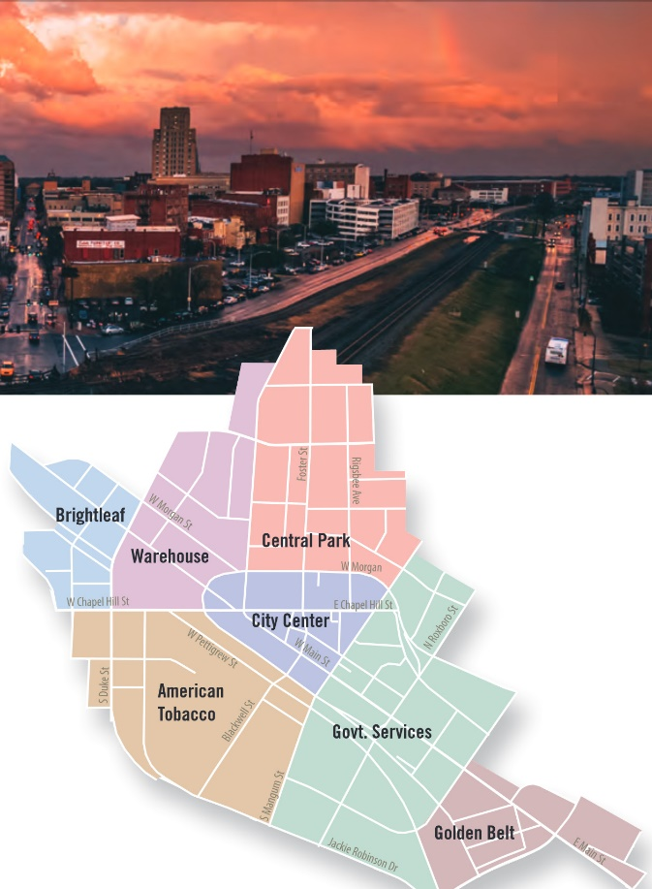
Restaurants in Downtown Durham - ride the Bull City Connector down Main St:

Mateo Bar de Tapas: Upscale tapas and wine bar. (109 W Chapel Hill St, Durham, NC 27701

Pizzeria Toro: Great place to enjoy a wood-fired pizza. (105 E Chapel Hill St, Durham, NC 27701)
Click here for a full visitor’s guide

Luna Rotisserie and Empanadas: South American | American South (112 W Main St, Durham, NC 27701)

Mothers & Sons: Chic Italian restaurant with robust wine offerings. (107 W Chapel Hill St, Durham, NC 27701)

Saint James Seafood: Fresh seafood and craft cocktails. (806 W Main St, Durham, NC 27701)

Roses Noodles, Dumplings, and Sweets: Some of the best ramen around. (121 N Gregson St, Durham, NC 27701)

Bars, Pubs, and Live Music:

The Federal: Local bar with relaxed vibe and late-night food. (914 W Main St, Durham, NC 27701)

The Bullpen: Great place to get a beer and listen to live music, partner of the Music Maker Relief Foundation. (359 Blackwell St Suite 135, Durham, NC 27701)

Fullsteam Brewery: Spacious local brewery that occasionally hosts trivia. (726 Rigsbee Ave, Durham, NC 27701)

Beyu Caffe: A cocktail and coffee bar in the heart of downtown, where you can also find some amazing jazz music. (341 W Main St, Durham, NC 27701)

For restaurants downtown, it is recommended that you make a reservation ahead of time.

Things to Do

While you’re at Duke
Dig into the archives.
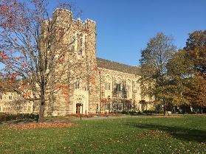
Pay a visit to the David M. Rubenstein Rare Book and Manuscript Library. The Rubenstein Library is located on Duke University's West Campus, alongside the William R. Perkins Library and Bostock Library. You can get to the Rubenstein Library by entering through the tower entrance. The reading room is straight ahead, after you pass through the stone foyer. Here is a map to guide you.

If you would like to request material for use in the reading room, please register as a researcher and review the policies found here.

Click here to see current exhibits on display in the galleries. A featured exhibit will be Five Hundred Years of Women’s Work: The Lisa Unger Baskin Collection.

Spend time surrounded by art.
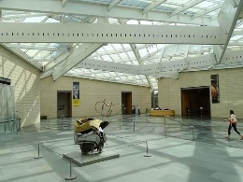
Stop by the Nasher Museum of Art. Since opening in 2005, the museum has been dedicated to presenting innovative and accessible collections, exhibitions, publications and programs that stimulate intellectual discourse, enrich individual lives and generate new knowledge. The Nasher is located on Campus Drive. Here is a map to guide you.

Click here to learn more about what will be on display, including the original traveling exhibition Pop América.

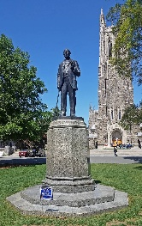
Visit the Duke Chapel.
Information about tours and services can be found here. Read about the decision to remove the statue of Robert E. Lee that was previously by the chapel steps here.

Stretch your legs and enjoy some fresh, North Carolina air.
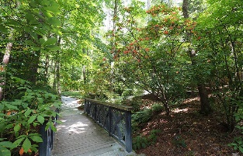
Get lost in the Sarah P. Duke Gardens, which recently celebrated its 75th anniversary. Here’s a map to guide you.

Take a lap around the Al Buehler trail, walking distance from conference activities.

Explore the 7,000 acre Duke Forest.
In Durham
Spend some time visiting historic sites and learning about local history.
- Durham History Hub: Learn more.
- Pauli Murray Center: Learn more.
- Hayti Heritage Center: Learn more.
- Historic Parrish St, Durham’s “Black Wall Street”
- Stagville State Historic Site: Learn more.
- Bennett Place: Learn more.

Catch a show at the Carolina Theatre.
See what’s playing here.

Learn more about local artists in some of Durham’s many gallery spaces.
- Carrack:
https://thecarrack.org/
- Durham Arts Council: http://www.durhamarts.org/
- Pleiades Gallery: http://pleiadesartdurham.com/
- Power Plant Gallery: http://powerplantgallery.com/

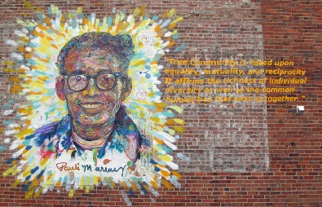
Do a mural tour across the city:
More information can be found here.

Getting Around

Maps – Duke and Durham

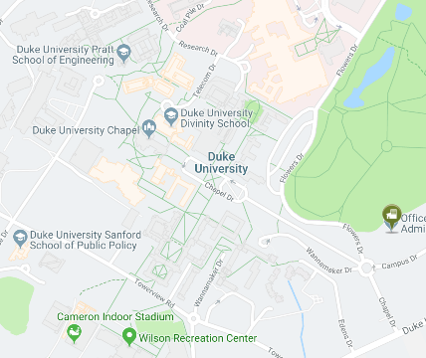
For those interested in exploring Duke’s Campus, here is a map outlining where everything is. Click here for greater detail. The LAWCHA 2019 Conference will largely be taking place on Duke’s West Campus. However, there are a number of academic departments located on Duke’s East Campus. East Campus is also walking distance from Ninth Street, where there are some local shops and restaurants. Other places to visit at Duke, such as the Nasher Museum of Art, the Duke Gardens, and the Rubenstein Arts Center are located in between the two campuses. Duke offers a free bus service to facilitate transportation between campuses. The C-1 East-West is the most direct route and can be picked up in front of the Duke Chapel. Bus routes and times can be found here.
For those wanting to hit the town, be it to visit a museum or gallery or just to wander around, the Bull City Connector (BCC) is a free bus that passes right near campus and goes all the way into the heart of downtown Durham. The BCC’s route and schedule can be found here. More information on restaurants and places to see in Durham can be found here.

Transportation
From the Airport.
For those who are flying into the Raleigh-Durham Airport, information about ground transportation can be found here. Rideshare companies such as Lyft and Uber are widely available, as well as local taxi companies such as Charlene’s Safe Rides, Durham’s Best Taxi Co., and RDU Taxi, Inc.

The easiest way to get to campus from the airport is to take I-40 W until you reach NC-147 N, and then stay on NC-147 N until you reach Exit 13. From there, you will see signs for the university.

To the Conference.
From the Millennium Hotel. 2800 Campus Walk Ave, Durham, NC 27705
The Millennium Hotel is approximately one mile from the Sanford School of Public Policy and is certainly walkable for those who want to stretch their legs before the conference begins. There is also a Duke bus that has a stop right in front of the hotel called the Lasalle Loop (LL). This bus will go to the Duke hospital, and from there it’s about a 15 to 20-minute walk across campus. The map can be found here. The Millennium offers a shuttle service for stops within a 5-mile radius of the hotel, and there will be limited parking for those who have or are renting a vehicle. Given that there will be limited seats on the hotel shuttle and limited parking available, it is recommended that you plan how you will travel to campus before the conference begins.

From the JB Duke Hotel. 230 Science Dr, Durham, NC 27708
The JB Duke Hotel is half a mile from the Sanford School of Public Policy. For those interested in walking, just go down Science Drive towards the Duke Chapel, and it should take approximately 7 minutes or so to arrive. The Sanford School will be on the right, directly across from the Law School.

